29.37:a)
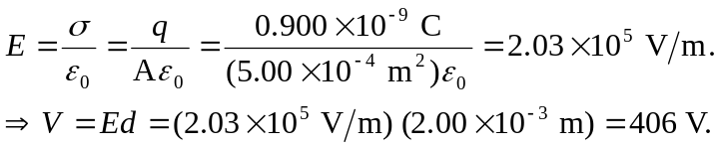
b) 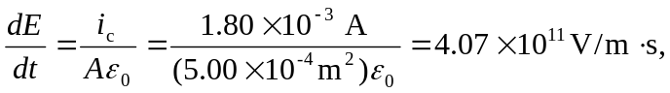 and is constant in time.
c) 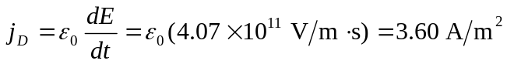
which is the
same as 